Standards-Based Grading (SBG) FAQ
Every math course at Uni will use Standards-Based Grading.
What is SBG? Standards-based grading is an educational system that focuses on the effectiveness of instruction and the mastery of skills or standards for a specific subject. This grading system allows students to understand which learning targets they have already mastered and which of the given standards still need to be improved.
What are the benefits to SBG?
- Values growth, progress, and learning
- Reduced student stress and competitiveness over grades
- Creates opportunities to differentiate within a classroom
- Makes instruction and planning more meaningful
How do I know what my student is learning? The standards for every math course are listed in PowerSchool. From a parent’s or student’s page, you will click on standards grades. If you hover over the title of the standard, it should give you a brief description of what the standard is about. Students also are provided with the standards prior to assessments. Students often love this because they feel they know exactly what they are being assessed on prior to walking into the assessment. An example of the standards from Math 3 Unit 1 is listed below:
1.A Understand and apply the function/function inverse relationship in graphical/tabular representations.
1.B Understand and apply the function/function inverse relationship in algebraic representations (including situations where the domain must be restricted).
1.C Understand and apply function composition.
1.D Understand and apply logarithms as inverses of exponential functions.
Students also are graded on common standards in every class throughout a course, which include:
C1 Communicate: Oral Present clear spoken arguments and descriptions of mathematical concepts and problems.
C2 Communicate: Reading Demonstrate that you can learn from reading, and that you can follow written instructions carefully.
C3 Communicate: Written Communicate about mathematical processes in writing, using good mathematics and good English.
C4 Notation Use correct notation and symbols in written work.
C5 Reasoning Reason mathematically; make sense of mathematical situations.
C6 Tools Choose and use appropriate tools for mathematics
C7 Collaboration Overall quality of the group's project submission; individuals from the same group may be graded differently.
C8 Model Use relevant mathematical concepts to model situations, and understand and apply the modeling process.
C9 Algebra Perform algebraic manipulations accurately and efficiently.
C10 Geometry Use geometric ideas and formulas from earlier units or courses appropriate to solving problems.
C11 Probability/Statistics Use ideas of probability and statistics from earlier units or courses to solve problems.
C12 Trigonometry Use trigonometric functions and their inverses in a variety of applications.

What types of grades will my student earn? Students will be given standards grades on summative assessments (test, quiz, project, presentation), but not typically on homework. (Homework is typically graded with points/percentages.) The standards grades a student can earn are:
  - E (exemplary work)
  - M (mastery of material)
  - R (revisit and reassess)
  - F (fragmentary understanding)
  - 0 (missing or irrelevant work)
You may also see a + or – listed with a grade (for example, M+ indicates mastery knowledge but closer to exemplary).

What is a “reassessment”? When a student earns an M- or lower on a standard, that student is allowed to reassess. This is one of the best things about SBG; students can try again to show they understand a concept. Most students feel that this process removes much of the stress and pressure of assessments. In order to “qualify” for a reassessment, a student must be earning at least a 51% on their homework. The student must correct the mistake on the original assessment that earned them the lower grade and also complete a few practice problems to prepare for the reassessment. Teachers are willing to help students correct mistakes and provide practice problems for them to prepare. A student should coordinate with their teacher on when reassessments take place, but students should take advantage of study halls, free periods, lunch, Uni periods, and Math Help (see below); teachers may also provide some time during class to reassess.
Will my student earn a semester letter grade in their math course? A student will earn an overall semester letter grade for the semester using a flowchart (also available on their syllabus). Each teacher may alter their flowchart slightly due to different course requirements, however an example from Statistics is below. Teachers will update these periodically throughout the semester, however it is important to know that PowerSchool will not update these semester grades automatically, so teachers do this manually. If you would like some explanation on a semester grade or feel there is an error, please reach out to your student’s teacher.
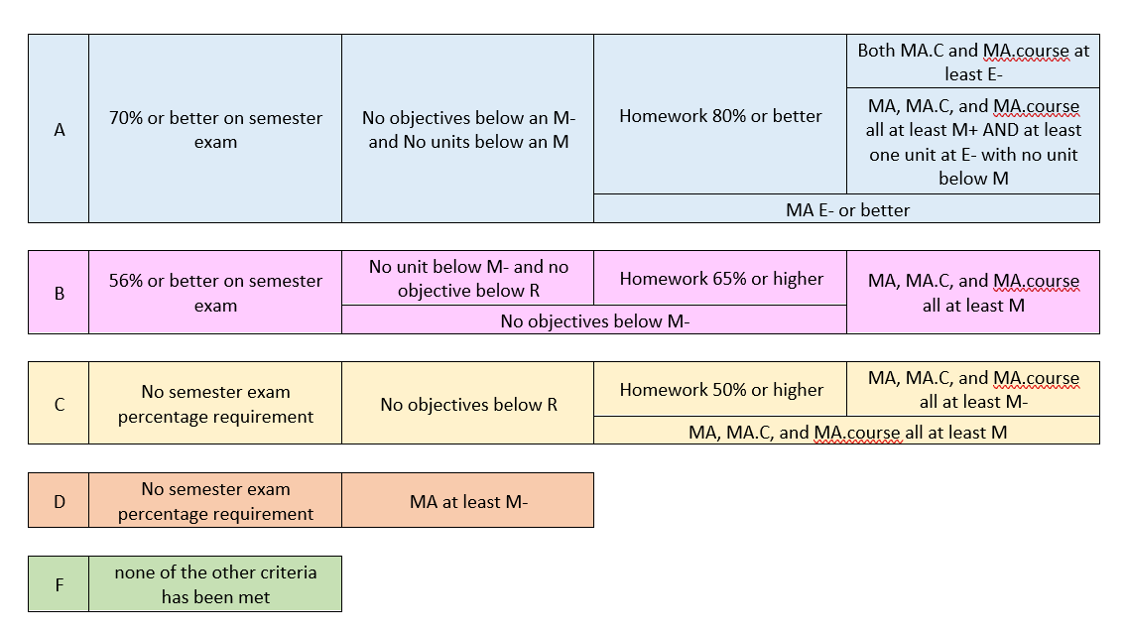
Where can my student get some extra help? Students are welcome to contact their teacher to set up times to meet to get extra support. The math department also volunteers time at Math Help, which is provided 1-2 times per week during Uni Period. Please see the Uni Period schedule for times.
Where can I learn more about SBG? Standards-Based Grading: Definition, Benefits & Comparison With Traditional Grading https://research.com/education/standards-based-grading#:~:text=As%20opposed%20to%20the%20traditional,accelerate%20mastery%20of%20learning%20standards.
What do I do if I have a question/concern? We always encourage parents and students to start with their teacher (see contact information below). If for some reason, you are not satisfied with the answer, you are welcome to email the Math Executive Teacher. After both of those avenues are explored, administration would be the next step.

Contact Information for Teachers:
Mrs. Emily Buhnerkempe (Mrs. B)
Math Department Executive Teacher, Math 1, Statistics
emilyeb@illinois.edu
Ms Jeleania Fields (Ms Purple)
Math 3, Advanced Topics
jeleania@illinois.edu
Ms Beth Runkel (Ms Runkel)
Calculus 1, Calculus 2/3
erunkel2@illinois.edu
Ms Kaila Simpson (Ms K)
Math 1, Math 2
simpso15@illinois.edu

