From the Curriculum Guide: The Mathematics department is committed to providing a quality program in college preparatory mathematics. We understand math as a language for describing patterns in the world around us. Students will learn this language through active participation. Critical thinking skills are developed in all courses, supporting students in their everyday and professional life. The Mathematics department is committed to equipping all students graduating from Uni with the prerequisites in mathematics to succeed in their chosen course of study at any university in the United States. The curriculum is integrated and aligned with the Common Core Standards for Mathematical content and practice. Faculty emphasize approaching problems from the numerical, geometric, and analytic points of view and developing the student’s ability to communicate about mathematics both orally and in writing. Students will value the role of both investigation and proof in mathematics and use technology where it is helpful in supporting these aims.

Math Department Philosophy: As a laboratory high school, we integrate current best practices in math education into our students' learning experiences. In all math courses students should expect to think critically by participating in groupwork every day. The world we live in requires collaboration to solve big problems. In teaching our students to work with a variety of students they will engage in student efficacy. Students will notice different ways to solve problems and talk about different methods that could be used. Uni math teachers value a deep understanding of the material which is enhanced when students share a variety of methods used to solve problems, rather than focusing on completing one method quickly.
Often students may be asked to work on surfaces other than paper (ie: chalkboards or individual whiteboards). In using vertical surfaces, students are physically more engaged in problem solving. Research has shown that the use of non-permanent surfaces increases the opportunities for all students to be involved, and teachers can differentiate more easily in real-time. Skills such as patience, communication, and perseverance are also built.
Some students may believe that they are not “math people.” We as a department do not believe this. It may be true that some students need more time with the material to understand it, but that does not make students “bad” at math. We believe in providing many opportunities for differentiation in our classroom time and through assessments, such as orally explaining, projects, or reflective writing.
Our department uses standards-based grading. Through this we can provide students multiple opportunities to learn a concept and allow a students’ grade to reflect that learning. It effectively communicates to students and parents what concepts (standards) students are mastering and what others need to be practiced and reassessed again.
For parents: Mathematics education has transformed in the last 20 years. No longer are students primarily sitting in a room, listening to a lecture, and writing down material. But that does not mean we are not teaching, and students are not learning. Deep critical thinking truly occurs when a student productively struggles with a problem. We as teachers are using a variety of techniques, such as the use of manipulatives, questioning, prompting with ideas, and structured supports to help guide students to solutions. This, along with standards-based grading, may feel very unusual to you, so please feel free to reach out to your student’s teacher with any questions.
Acceleration: Uni is a selective-enrollment high school for academically talented students, therefore all math classes are designed to be challenging. Integrated curriculum in the Math 1, 2, 3 sequence provides students an opportunity to see connections between geometry, algebra, trigonometry, and statistics. Differing levels of math understanding in a classroom provides an opportunity to promote student efficacy for every student. All incoming subbies will enroll in Math 1 and take the same Math 1, 2, 3 course sequence. After Math 3, students are offered a variety of paths tailored to student interests and levels of understanding; these courses include Statistics, Advanced Topics, and the Calculus sequence (see flowchart below).

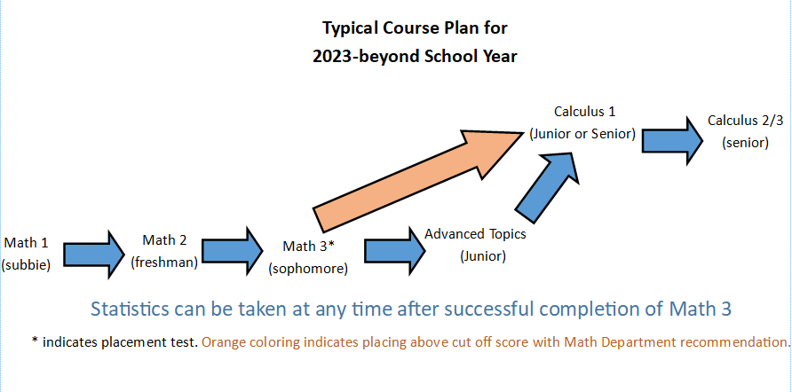

Last updated 5/23/2023

